**LOGO** (con link a home page) **ABOUT SOLUTIONS CAREERS SUBMIT ASSIGNMENT CONTACT**

(Home page – una sola imagen de impacto)

**WE GENERATE VALUE**

**FOR**

**THE INSURANCE INDUSTRY**

We provide valuable insurance and risk management services to insurance companies, self-insured corporations, claim adjusting firms and governmental entities.

**LOGO** (con link a home page) **ABOUT SOLUTIONS CAREERS SUBMIT ASSIGNMENT CONTACT**

(Segunda pagina – una sola imagen de impacto)

|  |  |  |
| --- | --- | --- |
| VISION (grafico con link a texto) | MISSION (grafico con link a texto) | VALUES (grafico con link a texto) |

Welcome to Engage Solutions – a vibrant young company born in the technology world and fueled by experienced insurance professionals with one objective:

**To provide an outstanding customer service to the insured, and the best professional support to the insurer along the claim cycle.**

The turnaround; higher customer retention and lower adjustment costs.

Our solutions are exactly that, solutions. We have the flexibility to provide you with a customized and evolving product to meet and exceed your needs.

**How can we help you?**

(Textos de vision, mission y values)

Our Vision

We intend to be the leading provider of P&C insurance adjusting and appraisal services on all markets we serve. Our secret: Our People. We are the best because we care.

Our Mission

To provide superior service through our network of highly skilled professional claims adjusters with focus on the most risk prone areas of the country. Our workforce is among the most experienced in the industry and prides itself on accurately reporting, investigation and administration of claims. Our efficient processes, timely response and fair solutions keep us at the forefront of a constantly evolving industry.

Our Values

We are continually searching for new and better ways to serve our customers. To accomplish our vision, we commit to the following values to guide all our decisions and behavior; among us and with all those we serve:

Integrity – Do the right thing, always

Quality – What we do, we do best

Innovation – Change is constant

Teamwork – Leverage collective genius

Passion – Committed in heart and mind

(nos gustaria mostrar nuestros valores graficamente, tal vez en una dona (como la de aqui abajo), donde el centro sea “Customer” y cuando el usuario pase con el mouse sobre cada franja, que esta se separe y muestre el texto explicativo)

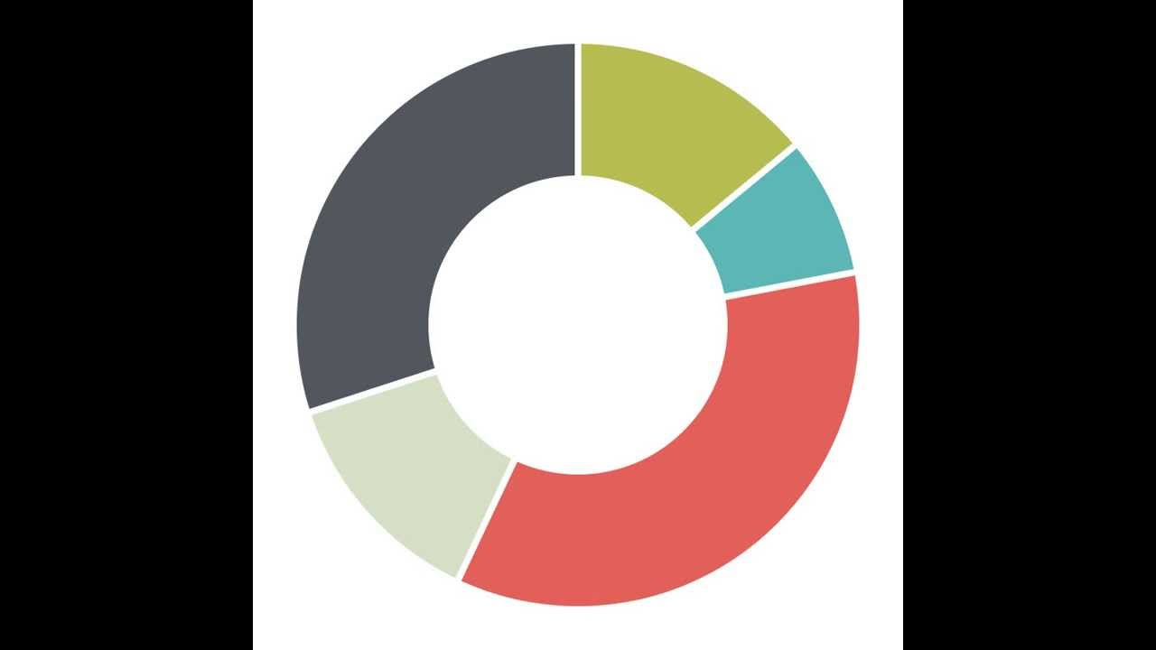

**LOGO** (con link a home page) **ABOUT SOLUTIONS CAREERS SUBMIT ASSIGNMENT CONTACT**

(tercer pagina – usar la imagen del tornado actual e incrementar el tamano de cada icono. Si el usuario hace click en el link queremos que ‘Solutions” sea vea completa en una pantalla)

SOLUTIONS

(Aqui van los 7 iconos con link a lost textos explicando cada servicio)

Textos “Solutions”:

DAILY PROPERTY

Engage Solutions provides residential and commercial property adjusting services for all types of losses. We will provide a knowledgeable and experienced team of adjusters capable of meeting your specific needs who are capable of handling losses of all sizes along with the most complex claim assignments.

CATASTROPHE

Engage Solutions mobilizes and dispatches adjusters to work catastrophe claims throughout the States of Florida and Texas every year. All our adjusters are HAAG Engineering Roof Inspectors Certified to make sure every claim is handled by the best and most experienced team.

THIRD PARTY ADMINISTRATION (TPA)/CLAIMS ADMINISTRATION

Engage Solutions provides Third Party Administration (TPA)/Claims Administration services for both personal and commercial insurance carriers. With a deep bench of experience in handling programs for insurance carriers, self-insured entities, program administrators, risk retention groups, and managing general agents, Engage Solutions is experienced at customizing programs specific to individual client needs, handling claims from first notice of loss through payment or as an outsourced claims overflow provider in catastrophes, our team can meet all your needs.

REINSPECTIONS

Engage Solutions realizes that disputes on a claim are a reality of the claims adjusting business. We make sure disputes are settled quickly and accurately. Our adjusters are trained to re-evaluate a loss with professionalism and attention to detail to fulfill each Insurance Company’s unique requirements.

APPRAISAL SERVICES

Insurance Companies and consumers have benefited from using the appraisal process for many years to resolve settlement disputes as an efficient and cost effective alternative to litigation. Engage Solutions utilizes skilled, impartial appraisers to reach an appropriate resolution.

FLOOD

Our team of flood-certified adjusters are the best trained, most experienced, and provide the best customer service in the business. Our reputation for quality work is unsurpassed in the industry. We pride ourselves on delivering the best experience we can to the policy holder, and to our carrier clients. Engage Solutions is capable of handling single assignment flood claims as well as handling a large quantity of claims associated with a large catastrophic flood event.

CASUALTY

Engage Solutions offers a broad range of casualty adjusting services including commercial liability, personal liability and product liability. Among the comprehensive services performed by this specialty team are full investigations, scene investigations and canvases, and witness location.

**LOGO** (con link a home page) **ABOUT SOLUTIONS CAREERS SUBMIT ASSIGNMENT CONTACT**

(cuarta pagina – usar la imagen del mapa de USA actual)

CONTACT US

Aqui queremos que resaltes todos los estados costeros con el Golfo de Mexico, es decir Texas, Louisiana, Mississippi, Alabama y Florida y en la Costa Este que resaltes Georgia, South and North Carolina. Queremos mostrar que ofrecemos cobertura en esos estados.

Our solutions are exactly that, solutions. We have the flexibility to provide you with a customized and evolving product to meet and exceed your needs.

ENGAGE SOLUTIONS, INC.

P. O. BOX 802724

Aventura, Florida 33280

1 (800) 977-3642

info@engagesol.com

**LOGO** (con link a home page) **ABOUT SOLUTIONS CAREERS SUBMIT ASSIGNMENT CONTACT**

(pagina separada con link desde el menu manteniendo el diseno actual donde se ve el mapa con la informacion de contacto)

SUBMIT ASSIGNMENT

(Usar el menu para ingreso de datos tal como esta creado)

We provide valuable insurance and risk management services to insurance companies, self-insured corporations, claim adjusting firms and governmental entities.

**LOGO** (con link a home page) **ABOUT SOLUTIONS CAREERS SUBMIT ASSIGNMENT CONTACT**

(pagina separada con link desde el menu – usar imagen de un arquitecto o ingeniero en una obra, construccion, planta o algo similar )

CAREERS

We are proud of our highly trained adjusters, most bilingual (English-Spanish), management leaders and administrative staff. We recognize the importance of industry leading training as part of our strategy to grow our market share; every person that works with us has an important role in servicing our clients' needs and is vital to Engage Solutions continued success. Engage Solutions supports and invests in the success of its adjusters and encourages them to reach their full potential.

Vamos a preparar una forma para que los candidatos la llenen online muy similar a lo que hiciste con “Submit Assignment”